CSCE 221 Cover Page
Programming Assignment #1
Due Date: Sunday October 6, 2019

Submit this cover page along with your report

First Name: Khoa Last Name: Diep UIN: 926005094

Any assignment turned in without a fully completed cover page will NOT BE GRADED.
Please list all below all sources (people, books, webpages, etc) consulted regarding this assignment:

CSCE 221 Students Other People Printed Material Web Material (URL) Other
1. 1. 1. 1. cplusplus.com 1. CSCE 121
notes
2. 2. 2. 2. Piazza.com 2.Previous code
3. 3. 3. 3. Stackoverflow.com 3.
4. 4. 4. 4. 4.
5. 5. 5. 5. 5.

Recall that University Regulations, Section 42, define scholastic dishonesty to include acquiring answers from any unauthorized source, working with another person when not specifically permitted, observing the work of other students during any exam, providing answers when not specifically authorized to do so, informing any person of the contents of an exam prior to the exam, and failing to credit sources used. Disciplinary actions range from grade penalties to expulsion. Please consult the Aggie Honor System Office for additional information regarding academic misconduct – it is your responsibility to understand what constitutes academic misconduct and to ensure that you do not commit it.

I certify that I have listed above all the sources that I consulted regarding this assignment, and that I have not received nor given any assistance that is contrary to the letter or the spirit of the collaboration guidelines for this assignment.

Today’s Date: 10/4/2019

Printed Name (in lieu of a signature): Khoa Diep

Introduction:

The objective of this project is to implement a Stack, an abstract data type, using at least three different implementations. The first implementation is building an ArrayStack, which is a stack using an array. When the array is full, ArrayStack will build a new array where it will increase the size of the array by a constant value and copying the contents of the new array into the new array. The second implementation is building a DoublingArrayStack. The DoublingArrayStack is similar to ArrayStack, but instead increasing the size by a constant amount when full, it will double the size. The third implementation will be building a stack using a linked list. We will then time each of these implementations and analyze these data structure.

Theoretical Analysis:

Each data structure has different performance time. Both ArrayStack and DoublingArrayStack will have to copy the old array. For ArrayStack, the push function works as such. It checks if the array is full. If it is full then the class builds a new array with a capacity of the old array plus 100 spaces. It then copies the contents of the old array into the new bigger array. It will then delete the old array, and then update the pointer of the old array into the new one. This is the copying step. The next step, will be the pushing step. It will store the content passed into the function into the next available space, which is known by topArray member of the class. It will then increment topArray by one, where topArray holds the element to the top of the stack.
ArrayStack let n represent the size of the array and c represent the constant value that we will have to increment the new array by when the stack is full (when the array is full). We let k = n/c, and k is the number of times we will have to build the new array and copy the contents from the old array. Then time needed to perform n pushes is denoted by T(n). T(n) = n + c + 2c … kc. The (n) in T(n) is equal to the number of elements added into the stack (number of pushes), and (c + 2c … kc) represent the number of elements copied from the old array into the new array.

T(n) = n + c + 2c +… + kc
T(n) = n + c (1 + 2 + … + k)
T(n) = n + ck(k+1)/2
T(n) = O(n+k^2), since k = n/c,
T(n) = O(n+ (n/c) ^2)
T(n) = O(n^2)
We can then conclude that the time complexity of ArrayStack on average is O(n^2)

Similarly, the push function for DoublingArrayStack is almost identical to the one. The only difference is during the copying step, when full the function creates an array with double the capacity of the previous array, not a hundred spaces bigger than the previous array. Solving T(n) for DoublingArrayStack, using the same notations from before, let i = initial size of the array when constructing DoublingArrayStack, and let k = log2(n/i) rounded up, which represent the number of times that we are replacing the old array is equal to n + i + 2i + 2^2i + ... + 2^ki. The (n) in T(n) is equal to the number of elements added into the stack (number of pushes), and (i + 2i + 2^2i + ... + 2^k) represent the number of elements copied from the old array into the new array.

T(n) = n + i + 2i + 2^2i + ... + 2^ki
T(n) = n + i(1 + 2 + 2^2 + ... + 2^k)
T(n) = n + i(2^k - 1)
T(n) = n + i(2n - 1)
T(n) = O(n + 2n - 1)
T(n) = O(3n - 1)
T(n) = O(n)
We can then conclude that the time complexity of DoublingArrayStack on average is O(n), which is also equal to the worse case.

Lastly, push function for LinkedListStack works completely different from the previous two. It doesn’t need to do any copying, so the function only needs to worry about the pushing step. It increments sizeList by one (needed in the previous functions). It then creates a temporary generic Node called temp. Then the data member of temp will hold the content passed into the function and next will point to head, where head points to the top of the stack, (or nullptr if the linked list is empty). Then head will point to temp. Since the push function has a time complexity of O(1), the LinkedListStack has with n amount of pushes, the time complexity is just equal to the amount number of pushes. Or T(n) = n = O(n)
T(n) = n
T(n) = O(n)
We can then conclude that the time complexity of LinkedListStack on average is O(n), which is also equal to the worse case.

The advantages of ArrayStack, is that every time the array gets copied, it only creates a constant amount of space on the heap. This means that this ArrayStack is consistent in terms of how much memory is allocates when building this stack. However, its disadvantages heavily outweigh the advantages. As shown above the time complexity of ArrayStack is n^2. ArrayStack that it grows quadratically, where DoublingArrayStack and LinkedListStack grows linearly. This means ArrayStack is the slowest implementation as number of pushes approaches infinity. This is not optimal because for stacks, we want stacks that can hold a large number of elements.

The advantages of DoublingArrayStack is that the time to push large number of objects will be the lowest out of the three implementations, since putting an object into an array is a very fast process and it has a time complexity of O(n). However, the disadvantage is that as the number of pushes gets larger, so does the capacity of the array. This could result in a very large array, which could result in allocating space on the heap that will never be used. For example, let say we have capacity of the stack at 2,000,000, but we want to push 2,000,001 objects into the stack, which is also the arbitrary maximum amount of pushes. We would have to double the capacity of the stack, which the capacity of the stack will be 4,000,000. We would have 1,999,999 elements of the array on the heap that will never be used. Thus, this could be intensive in memory.

Lastly, every time an object gets pushed into the stack, we would only need to allocate memory of one node, which is more efficient in terms of memory, then ArrayStack and DoublingArrayStack, also the time complexity is O(n), so it will be faster than ArrayStack in general. However, the push function for LinkedListStack is more complicated than the other two, it has to create a new node and updating its data member, is more complicated then storing an object into an array. Thus, in theory, LinkedListStack should slower than DoublingArrayStack, when Doubling ArrayStack doesn’t need to copy a lot as the number of pushes gets larger.

Experimental Setup:

I tested on my laptop, which has a Intel Core i7 processor, 16 GB of RAM, and operating on Windows 10. An IDE called Eclipse is used to compile and write the project. In order to test the functions, I created three stacks of each type. For all three, I used a for loop to push, test the size() function, and use cout to determine pop() and top() in main.cpp. For timing the amount of time with n number of pushes, I used chrono in the standard library, since StopWatch.h was giving me trouble.

The test inputs used were 10,000 to 200,000 in increments of 10,000 for each implemented stack. The initial Stack size for both ArrayStack and Doubling ArrayStack is 100 and the increment amount for Array Stack is one hundred. I started at 10,000 since we can see the difference in speed between ArrayStack and DoublingArrayStack since Array Stack would have to go through the copying step a hundred time, whereas the DoublingArrayStack would only go through the copying step 8 times. I incremented by 10,000 times in order to be consistent in term of the increment amount of the ArrayStack. This means that the ArrayStack will always be full for every input to be consistent.

I repeated this experiment ten times, and recorded and plotted the averages after taking out some the outliers.

Experimental Results:

Graphs

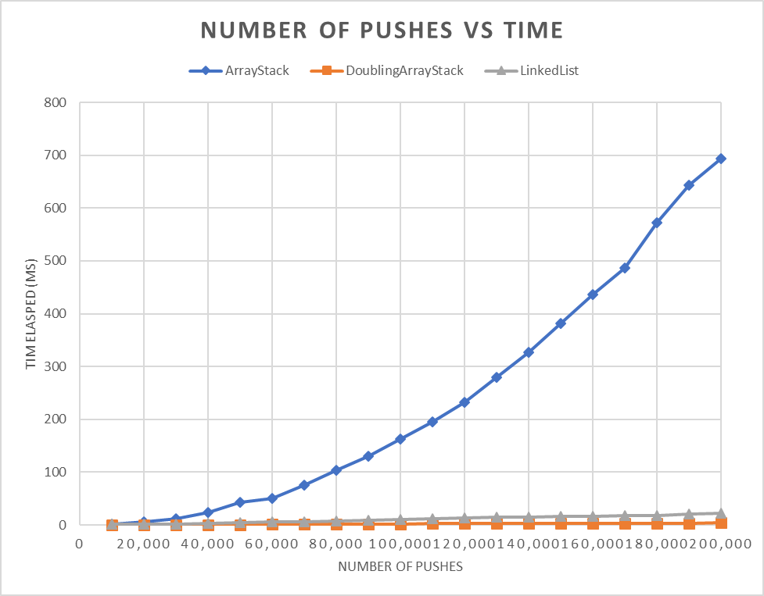
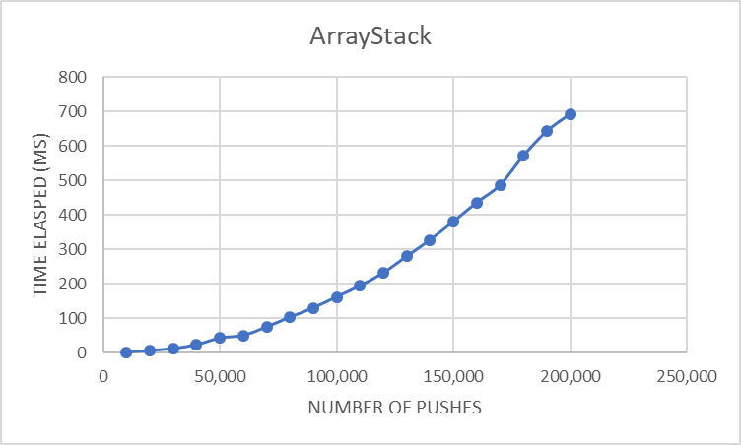

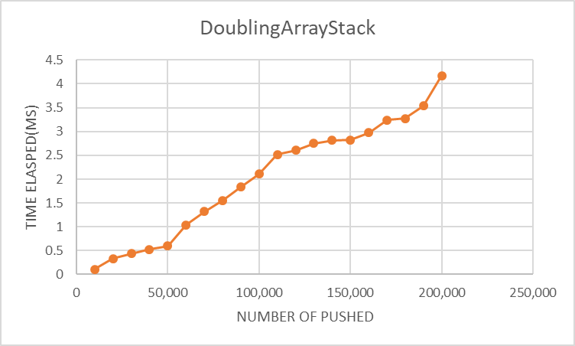

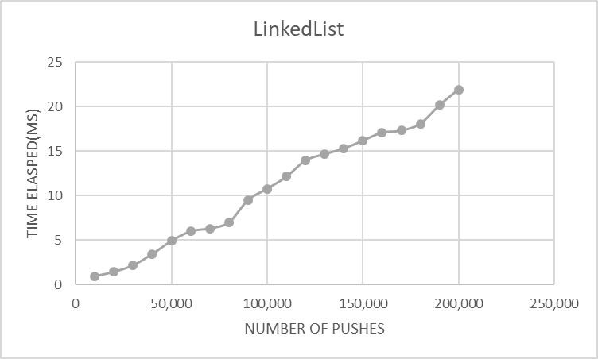

Results:

The DoublingArrayStack performed the best in general, which supported the theoretical analysis. This does not depend on input, and the graphs supports it. This is probably because the complexity of a inserting into a linked list is in general more complicated than a inserting into an array, and the doubling array does not need to copy often. It does not come as a surprise that the ArrayStack is the slowest one out the three, since it has to copy the old array into the new array frequently. This is also shown previously during my analysis, where T(n) = O(n^2). My theoretical analysis mostly proven by the data. However, I thought that maybe the linked list would be faster as the number of pushes is lower (e.g. 10,000). Perhaps that 10,000 is too large of a number to start and start graph at a lower number like 5000 or 2000 in order to test my theory. Other than that, my analysis is backed up by the data.

